By Kenneth Welch, Founder, Open Government in Blanco County TX,
https://www.opengovernmentinblancocountytx.org, September 19, 2023

INEXPERIENCE, OR A BIG PROBLEM IN BLANCO CITY GOVERNMENT?

Mayor Mike Arnold took office on May 16, 2023. He had not served in an elected position previously, and based on what we have seen during his first four months, we have to ask: does he understand the sunshine laws which require transparency in all public matters?

TEXAS OPEN MEETINGS ACT AND MAYORAL DUTUES:

The Texas Governmental Code, Chapter 551 Open Meetings requires deliberations on public issues to be conducted in open meetings accessible to the public. "A Governmental Body Must Hold a Meeting to Exercise its Powers. Predating the Act is the common-law rule that decisions entrusted to governmental bodies must be made by the body as a whole at a properly called meeting."

Section 22.042(c) of the Local Government Code states: "The mayor shall give to the governing body any information, and shall recommend to the governing body any measure, that relates to improving the finances, police, health, security, cleanliness, comfort, or good government of the municipality"

Two significant situations have arisen in the Mayor's four short months of tenure wherein he failed to conform to governmental practices dictated by statutes. Without discussing the issues with the City Council, he advised TxDOT of a preferred US 281 relief route and simultaneously established and began meeting with a Financial Tansparency and Security Committee.

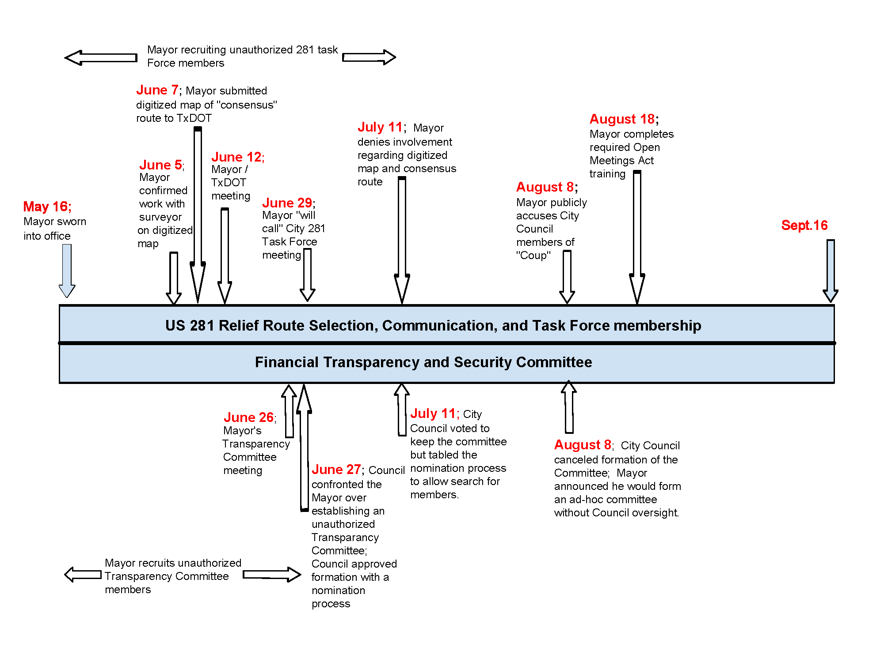US-281 RELIEF ROUTE IDENTIFICATION:
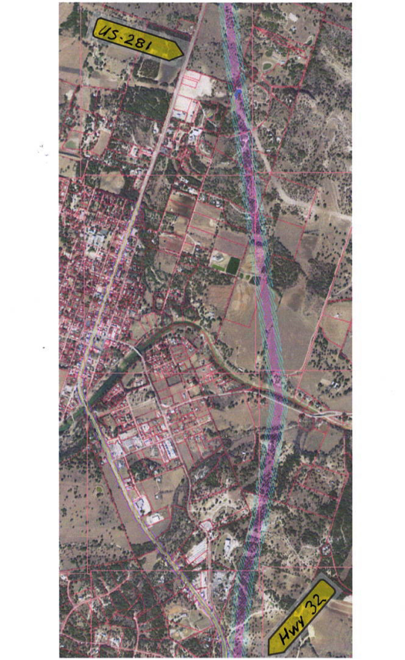
On June 7 Mayor Arnold communicated directly with the Texas Department of Transportation (TxDOT) wherein he indicated community consensus on matters pertaining to a potential relief route around Blanco for US 281. With a series of emails and text messages the Mayor prepared for a June 12 meeting with TxDOT, without any interaction or direction from the City Council. The Mayor emailed a digitized map to TxDOT showing the route that he championed. He also gathered a set of route maps created by citizens following an article in the Blanco County News in the fall of 2022. None of the maps from the citizens had been created by Mayor Arnold and none were in a digitized format.

Also in preparation for the June 12 meeting with TxDOT, Mayor Arnold began recruiting a group of citizens to form a new committee to work with TxDOT. On August 9, 2022 the former City Council created a Highway 281 Task Force consisting of various city officials and other members of the community to be appointed by the City Council. Mayor Arnold, as the new Chair of that task force, has never communicated with the previously appointed members, never called a meeting, and has not addressed the City Council to re-constitute the task force. Instead he invited members from the community whom he wanted on the committee stating: "I'm going to re-make the City's 281 Alternate Route Task Force." He noted in one of his text messages: "TXDOT is starting an official one, and I have 100% control of it. The Council has theirs, to which they (not I) appoint members, but I'm the chair...so if they don't make it how I want it, I just won't call a meeting, and we'll just drive 100% with the state Task Force."

At the 'Mayor's Coffee' on June 29th, after establishing his new task force and meeting with TxDOT, the Mayor confirmed that a task force set up by the former city council exists. He further stated his intention to call a meeting of that task force after finalizing the City's 2023-24 budget.

CITY COUNCIL CONFRONTATION OVER US-281 RELIEF ROUTE:

During the July 11th City Council Meeting members of the Council confronted Mayor Arnold about his actions. He said he had only sent maps submitted by citizens with "no editorial comments; this is what we got." However, his earlier email exchanges with Megan Dutton, P.E., (TxDOT Advanced Project Development), clearly laid out the circumstances which took place. A text message to a local land surveyor during the week of June 5th indicated that he had worked on the digitized map when he requested a "copy of that alternate route map we did awhile back?" The Mayor also indicated he was sending the map to TxDOT ahead of their meeting on June 12.

At the next City Council meeting on August 8th Mayor Arnold offered what he called a "little background" on the US-281 TxDOT communication. Speaking to those members of the public in attendance he said, "You all have been manipulated, I never put forward a proposed route, I never drafted a route...the map that I saw waved around, attributed to me, I didn't do this map. This was printed by TxDOT and handed to me at a meeting about a week after that email that was taken out of context...My comments and my actions were taken out of context to gin up a political coup." He went on to say: "The consequences are dire. The fact is, TxDOT is now cutting us out of the loop on this conversation."

The map that Mayor Arnold held up was, indeed, a map that TxDOT had printed and provided to him during their June 12 meeting. However, superimposed on it was the digitized route that Mayor Arnold had sent to TxDOT on June 7, 2023.

FINANCIAL TRANSPARENCY AND SECURITY COMMITTEE:

A second parallel initiative was occupying the Mayor's time during the early weeks of his administration. He formed a Blanco Financial Transparency and Security (FTS) committee prior to discussions in an open meeting of the City Council. Text message exchanges document that Mayor Arnold violated the intent of the Open Meetings Act and his duties as mayor when he acted independently to select members of his FTS committee. He went so far as to call and hold a meeting of his selected members on June 26, 2023 to "set plans for how to function and move forward, and get an overview of the issues we need to look into." However, text message dialogue and the committee makeup revealed a more sinister purpose for the committee than the Mayor later proclaimed.

The next day, at the June 27th City Council meeting the Mayor proposed the formation of his FTS committee. When confronted about already holding a meeting of his committee he explained that was just an informal gathering of a few friends. After the Mayor indicated that the first objective of the committee would be to obtain "Transparency Star Certification" from the State Comptroller's office, the Council authorized formation of the committee. However, they also defined a process to select members of the committee, effectively negating the membership Mayor Arnold had established.

At the July 11th City Council meeting Gary Courier, who hosted the first committee meeting, explained the goals of the committee. He presented a proposal to "Assist the City and Finance Director..., Assist the City...with greater & easier access to information..., and investigate discrepancies about past financial transactions.” A vote to end the committee was defeated and the appointment of members was tabled to permit all council members time to identify qualified nominees.

CONFRONTATION OVER FINANCIAL TRANSPARENCY COMMITTEE:

Leading up to the August 8 meeting, the content of the text messages became well known and revealed a more "investigatory" focus for the committee rather than one of administrative assistance. A motion to end formation of the committee was put forth. Council discussion centered on the burdens placed on staff rather than assistance to them. It was also noted the purpose of the committee differed from the stated goals.

Following the vote which stopped the creation of the committee, Mayor Arnold immediately said "I will officially appoint these people to an ad hoc committee with the same mandate, and work with them without your oversight.” It appears the Mayor still did not understand the intent of the Open Meetings Act requiring that "decisions entrusted to governmental bodies must be made by the body as a whole at a properly called meeting." He was also not fulfilling his duties as stated in Section 22.042(c) of the Local Government Code requiring that he "recommend" measures to the City Council. Section 22.042 also states "the mayor shall at all times actively ensure that the laws and ordinances of the municipality are properly carried out."

BIG PROBLEM OR A LEARNING CURVE:

The Open Meetings Act requires that all elected officials complete training on the requirements within ninety days after taking office. Mayor Arnold completed the training on August 18, 2023; ninety-four days after taking office. A review of the timeline of events clearly shows that all of these incidents took place before he completed the required training.
It is not clear what the Mayor's motive was for conducting these improper actions without City Council involvement. Was it based on his 'get something done' approach? Was there some personal motivation to set the specific relief route? Or, was it a case of incompetence or lack of familiarity with the Open Meetings Act provisions on how decisions are made by, and for, a municipality?

These repeated failures to comply with state statutes should be of concern to all community residents. The Mayor has now completed the required training and, therefore, I am hopeful that issues will be handled in the open, with full transparency, and resulting in the best possible outcomes.

--------- END --------

Open Meetings Act Handbook - 2022 - pg. 1 (I. Introduction, B. A Governmental Body Must Hold a Meeting to Exercise its Power)

